Submission Proposal For Timber Press

The Mycology of Cannabis
by
Kyle Kaszynski and Brandon Potter
Overview:
The primary goal of this book is to educate the cannabis industry on the intricate interactions between fungi and the cannabis plant. As cannabis and medical marijuana gain mainstream acceptance, the demand for reliable information to educate consumers will inevitably increase. Currently, the cultivation community is often plagued by misinformation, perpetuated largely by online forums. This book aims to address these issues by providing accurate and accessible information.
The book will begin with a comprehensive overview of fungi, covering their fundamental biology, growth patterns, and diverse ecological roles. Following this introduction to fungal biology, we will delve into the specific interactions between fungi and the cannabis plant. This section will open with a discussion of beneficial symbiotic relationships, exploring how both the plant and the fungus mutually profit. Key examples such as mycorrhizal fungi and fungal endophytes will be examined in detail.
Subsequently, we will address fungi that are commonly present in cannabis environments. While these fungi may not directly interact with the cannabis plant, they exert significant influence. This segment will cover common soil fungi and fungi crucial to composting and fermentation processes. Additionally, we will briefly explore other fungal associations, including lichens and dark septate endophytes.
A critical focus of the book will be fungal pathogens, a topic of paramount importance to cannabis cultivators. Fungal diseases represent a major challenge for cannabis farmers. By providing a thorough understanding of fungal biology, growth, and life cycles, this book will empower growers to more effectively manage these resilient organisms in their gardens. This section will offer in-depth information on the biology of prevalent fungal pathogens, such as powdery mildew, Botrytis, and damping-off fungi. Furthermore, we will critically evaluate available antifungal products, discussing their effectiveness and modes of action.
The concluding section of the book will equip readers with practical techniques for working with fungi. This will include methods for identifying fungi on plants and in soil, as well as culturing and propagating fungi for the production of fungal inoculants. Given its importance in mycology, the use of microscopes will also be covered, emphasizing their value and providing guidance on their proper application.

Table of Contents:

Introduction to The Mycology of Cannabis
Section 1 Introduction to Mycology
Chapter 1 What is Mycology- Introduces readers to the subject of mycology.
Chapter 2 Fungal Characteristics- Discusses traits and morphologies unique to the fungal kingdom
Chapter 3 Fungal growth- Describes the two primary growth morphologies found in fungi
Chapter 4 Fungal lifestyles- Covers major fungal life styles such as: mutualistic, commensal, parasitic, and saprophytic
Chapter 5 Fungal taxonomy- Introduces readers to basic taxonomy and why nomenclature is important in mycology
Chapter 6 Fungal Reproduction- Educates readers about how fungi reproduce and why they are so successful

Section 2 Beneficial Fungi
Chapter 7 Mycorrhizae- Fungi that grow into or around plant roots that help the plants gain resources while giving the fungus carbon in return
Chapter 8 Fungal Endophytes- Fungi that live inside the tissue of plants without causing any apparent harm
Chapter 9 Saprophytic fungi- Fungi that degrade dead organic materials and are the worlds ‘grand recyclers’
Chapter 10 Entomopathogenic fungi- Fungi that are carnivorous and can consume insects as a food source
Chapter 11 Fungi as viral vectors- Studies have shown that certain fungi can act as a vector, infecting plants with beneficial or pathogenic viruses and viroids

Section 3 Fungal diseases
Chapter 12 Powdery Mildew- Fungal disease caused by Podosphera species
Chapter 13 Bud-rot- common Fungal disease in mature flowers caused primarily by Botrytis cinerea
Chapter 14 Damping off- Disease which commonly infects newly emerged seedlings, quikly killing the plant
Chapter 15 Crown & root rot- Includes many fungal diseases such as Fusarium wilt
Chapter 16 Hemp canker- Fungal disease unique to cannabis cultivators
Chapter 17 Leaf spots- A once rare fungal disease in Cannabis culture, this disease can display symptoms that may look like nutrient issues
Chapter 18 Post-harvest contamination- Even after Cannabis plants have been harvested, fungi can still contaminate products if it is not dried and stored properly

Section 4 Defending Against Fungal Pathogens
Chapter 19 Plant defenses- Plants have the natural ability to defend themselves against fungal pathogens
Chapter 20 Prevention of disease outbreaks- The key to preventing disease and crop loss is to prepare and prevent fungal pathogens from infecting your garden
Chapter 21 Aerial and Foliar Treatments- If fungi do infect plants, here are some tried and true methods for minimizing crop loss

Appendices:
Glossary
Relevant Fungal Taxa
Common Fungicides allowed in Cannabis production
Cultivation protocols
Bibliography
About Us

About Us:

Kyle completed a bachelor’s degree in Plant Biology with a minor in chemistry from Southern Illinois University. He then received a master’s degree from University of Wisconsin-La Crosse in Mycology where his master’s thesis was focused on sustainable cultivation of edible mushrooms. Kyle has been experimenting with Cannabis cultivation and organic agriculture for over 15 years. Mr. Kaszynski has worked in hydroponic garden stores, consulted and worked in research and development for several fertilizer companies, and is certified crop advisor, certified lab technician with the Soil Food Web and is the lead mycologist for several companies.

Brandon received a B.Sc. in Biology from the University of North Carolina at Asheville. He remained in Asheville to work as a research technician with the United States Forest Service at Bent Creek Experimental Forest several years following. After which, he received a M.Sc. in Biology from the University of Wisconsin -La Crosse. Throughout his life and education he was drawn to the fields of botany and agriculture which led naturally to plant pathology and mycology. In addition to a formal background in biology and scientific research, Brandon has over 15 years experience in growing and working with Cannabis across a large variety of cultivation styles and scales. He has been breeding autoflower cannabis strains and producing seeds for the past 8 years.

Sales/Marketing:

This book will be a comprehensive guide to fungi that interact with the Cannabis plant. The target audiences will be Cannabis cultivators and enthusiasts from a non scientific background, as well as students and educators. There is not much science-based literature about Cannabis cultivation and as the plant becomes more widely accepted and cultivated there will be a need for resources like our book.

Once published, we would like to give presentations at some of the industry's top events about the subject matter and promote the book. Brandon and I would also like to maybe do a video series that discusses some of the topics in more details or updates materials as new data comes out.

Comparable Titles:

The ‘Teaming With’ series by Jeff Lowenfells
Mycorrhizal Planet by Michael Phillips
Diagnosing Hemp and Cannabis Crop Diseases by Shouhua Wang
Marijuana Botany by Robert Connell Clark

Manuscript Length and Illustrations:

Currently the manuscript is about 180 pages (including images and charts) and has 38,216 words. We have received permission for all images used in the manuscript and have paid an artist for needed lifecycle diagrams and cover art.

Example of life cycle diagram:
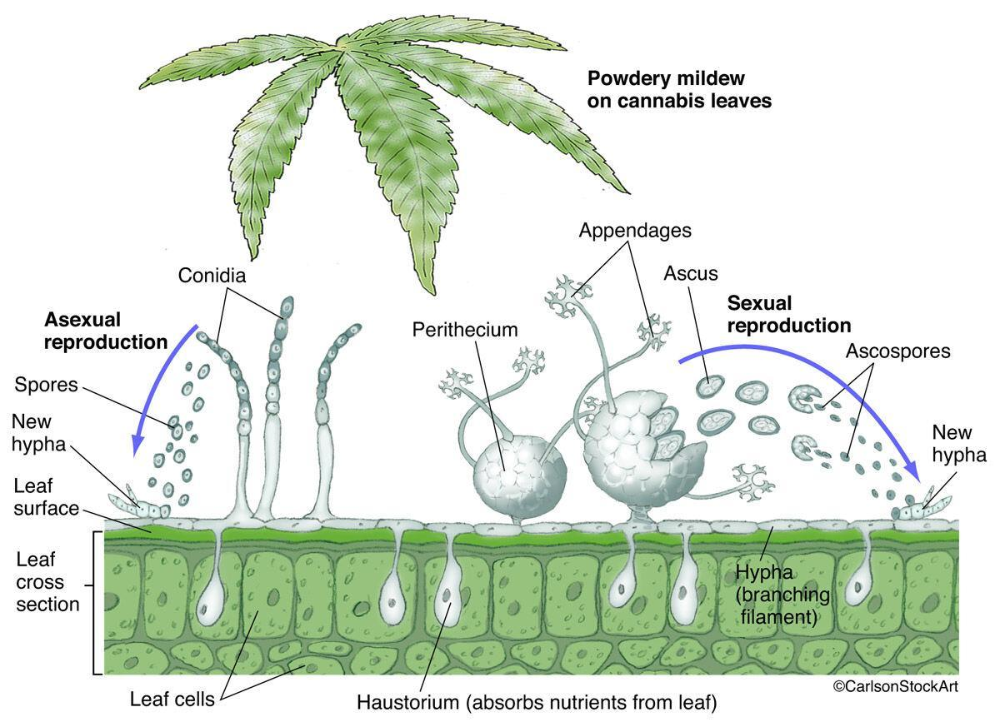

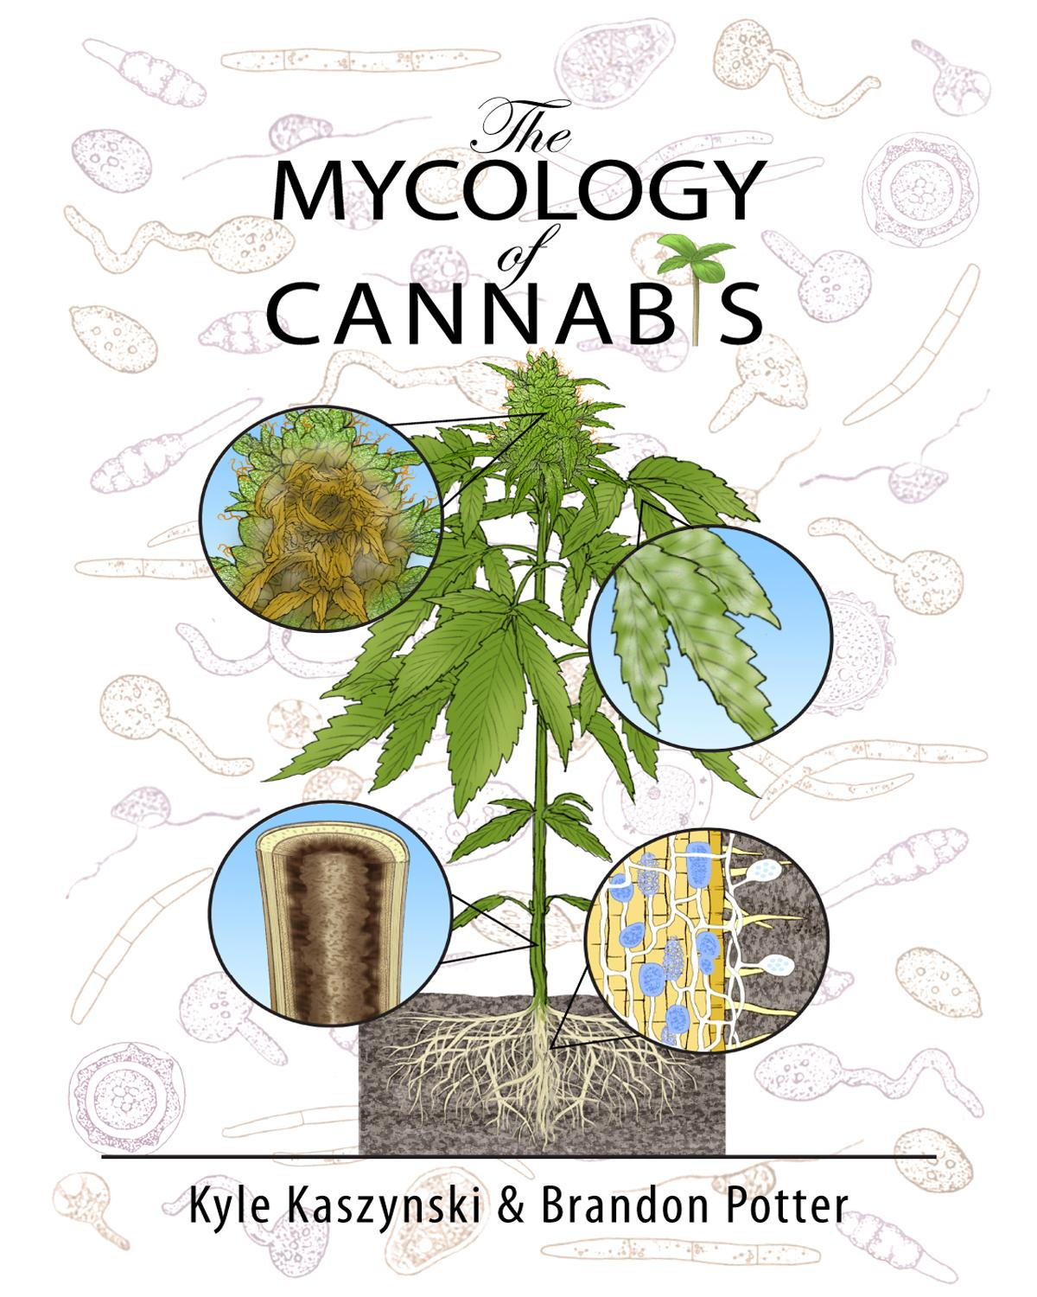

Sample Chapter
Chapter 2
Fungal characteristics

Gowers Notes:
· Fungi reproduce via spores
· Fungi are a distinct lineage from both plants or animals, though are closer related to animals than to plants
· Fungi have cell walls that are chemically different (composed of chitin) than the cell walls of plants (composed of cellulose)
· Fungi do not produce their own food so must release enzymes to break down complex food sources and the reabsorb the nutrients

Some physical and physiological characteristics of fungi can be useful in identifying fungi to various levels of hierarchical classification. Farmers with an understanding of fungal characteristics are also at an advantage in manipulating them to the benefit of their crop. In this chapter we will be discussing different anatomical features that researchers and growers can use to help identify the particular fungus with which they are working. We will be describing some of the key features that make a fungus a fungus, and not, for instance, a plant. The goal of this chapter is to educate readers of fungal traits.
Historically fungi have been grouped closely with plants. To this day, within academia, fungi are generally reserved for the purview of the botanists. Universities with a “Department of Mycology” are exceedingly rare. When a university department or college does include “mycology” in its title, it is almost always paired with the “botany” or “plant pathology” department. Though in hindsight there is an unintentional logic behind this, as these two kingdoms are intimately linked in practice through symbioses, the original grouping of fungi and plants together was an academic mistake.
Fungi superficially grow similarly to plants, with macroscopic forms appearing as sessile organisms with cell walls similar to plants and dependent on dispersal of reproductive structures for survival. Botanists, beginning with Pier Antonio Micheli, who published Nova plantarum genera in 1729, were the first western scientists to pioneer the study of fungi. Pier Antonio Micheli was the first person to show fungi reproduce via spores. Before his experiments showing that spores transferred to a new substrate gave rise to the same species of fungi from which they came, the dominant view had been that fungi spontaneously generate.
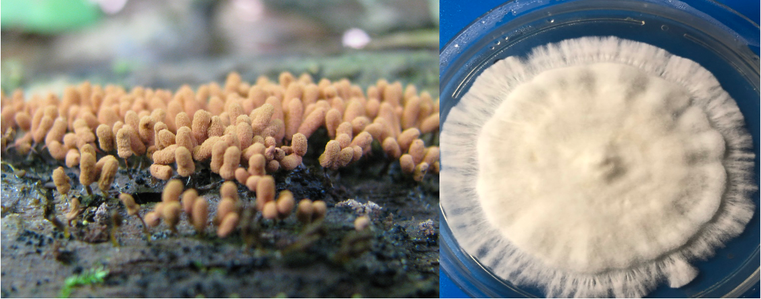
Fig. 2.1 Slime mold (left) vs a true filamentous fungus, Psilocybe spp. (right).
Throughout most of history fungi were considered lower plants. Ironically, this tradition of grouping unrelated organisms within an unrelated field continues; the Amoebozoid ‘slime molds’ (Myxostelida, Dictyostelida, Labyrinthulida, and Plasmodiophorida) and the Chromistan ‘fungi’ (Fig. 2.1) are not true fungi. Nonetheless, the similarity of physical appearance, growth characteristics, and economic impacts of these organisms reinforce their retention as a related field to mycology (and likewise mycology to botany).

Table 2.1. Hierarchical classification of 3 domains of life.
Domain | Kingdom | Members
Bacteria | Bacteria | Actinobacteria (Actinomycetota), Proteobacteria (Pseudomonadota), Cyanobacteria (Cyanophyta), Spirochaete (Spirochaetota), ect.
Archaea | Archaea | Extremophiles, methanogens
Eukaryota | Excavata | Various flagellate protozoa
 | Amoebozoa | Most lobose amoeboids and slime molds
 | Opisthokonta | Animals, fungi, choanoflagellates
 | Rhizaria | Radiolaria, and various other amoeboid protozoa
 | Chromalveolata | Stramenopiles (Brown Algae, Diatoms etc.), Haptophyta, Cryptophyta (or cryptomonads), and Alveolata
 | Archaeplastida | Land plants, green algae, red algae, and glaucophytes

Plants and Fungi
The relatedness of fungi and plants has stumped scientists for generations. In the past, scientists were only able to observe morphological characteristics in these organisms and did their best to group them based on these features. Chemical taxonomy helped prove that fungi were physiologically distinct from plants in numerous ways (Figure 2.8). The aid of molecular genetic sequencing techniques has recently helped further unravel the many mysteries about the relatedness of fungi. Organisms once believed to be fungi have been reclassified as protozoa (including oomycetes and the mycetozoan slime molds,); organisms believed to be protozoa (such as Chytrids, Microsporidia, and Pneumocystis jirovecii) were shown to be fungi. Protozoa itself is a catch-all group of single celled organisms that is non-monophyletic, meaning the grouping contains organisms descending from separate ancestral lines. Therefore it serves only as a classification rather than a systematic grouping representing phylogeny.
As stated before, plants and fungi share a number of similar characteristics but there are also some key differences between the two. To begin, both organisms are eukaryotic with membrane bound organelles, including a nucleus that houses the genetic material, deoxyribonucleic acid (DNA). However, fungi have relatively small nuclei with little repetitive DNA. Fungi can have one to many nuclei per ‘cell.’ Often these are genetically distinct nuclei when plasmogamy (the fusion of independent mycelial bodies) has occurred in the individual's history. Previously, separate individual mycelia may merge together in this way if they have appropriately-matched vegetative or mating compatibility types. Fungi usually have haploid
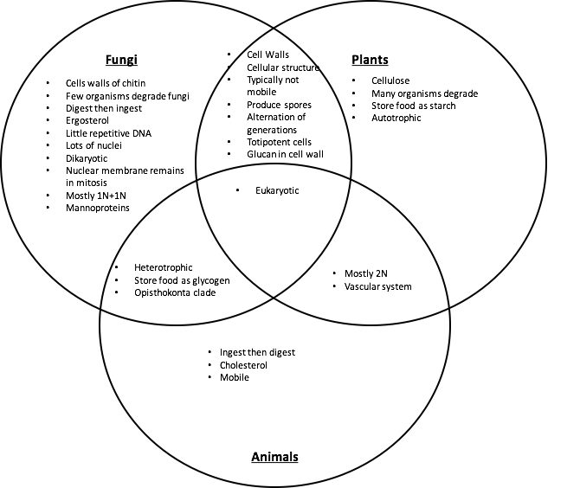
Figure 2.2. Venn diagram comparing similarities and differences of fungal, plant, and animal characteristics.

nuclei, even when two (or more) genetically unique nuclei coexist in an individual. Karyogamy (nuclear fusion) resulting in 2n nuclei only occurs in certain cells within fruiting bodies. These 2n nuclei form preceding the sexual production of gametes via meiosis. Higher plants have relatively large nuclei that are often diploid in all cells except the gametes, pollen and ovules. This is similar to animals.
A structure that both plant and fungal cells produce, and which serves many of the same functions, is the cell wall. The cell wall permits both plants and fungi to form sturdy structures capable of above ground growth by adding rigidity to tissue. Cell walls also assist in growth through physical substrates by permitting turgid fungal hyphae and plant tissue to exert outward osmotic pressure without the cell membrane rupturing. This is a crucial factor for the apical growth of hyphae among fungi through a physical substrate (Money, 1995), as it is in root tips and pollen tubes among plants. Additionally, cell walls serve to protect the cellular components and organelles found within. Despite similarities in function, the composition of the cell walls fundamentally differs between plants and fungi. Plants have cell walls composed of cellulose (and sometimes lignin) whereas fungi have cell walls of chitin.

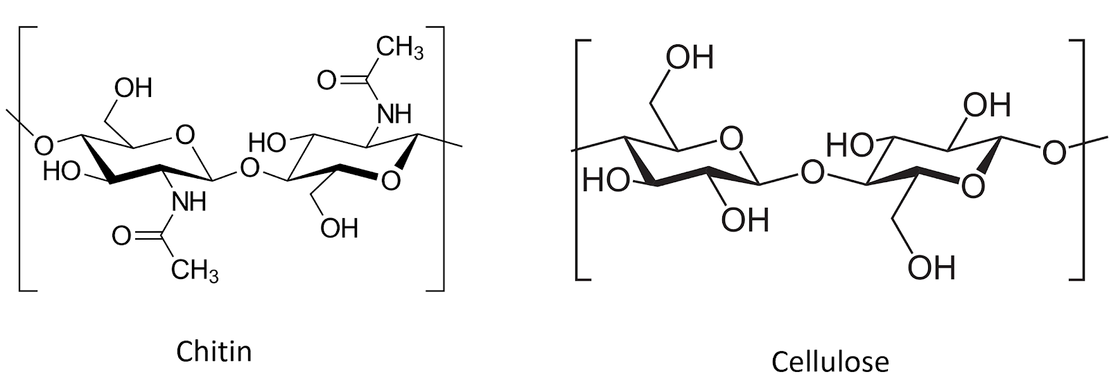
Figure 2.3. Chitin and cellulose are both polysacharide chains of β1-4 linked monosacharide monomers. Chitin comprises chains of N-Acetylglucosamine monomers, whereas cellulose is made of D-glucose monomers (graphic from wiki commons).

Due to the rigidity of the cell walls, both plants and fungi are generally sessile (non-motile) when mature. As sessile organisms, the lifestyle of plants and fungi are much different because of how each must acquire food. Plants are photoautotrophic and therefore able to produce their own food by utilizing sunlight energy to fix atmospheric carbon via photosynthesis into sugars. They also rely on root systems to gather essential elemental nutrients from the medium in which they grow. Plants metabolize sugars via cellular respiration as a source of stored energy. They also use the sugar they create, along with elemental nutrients from the soil, as substrates to synthesize the complex organic compounds their bodies require to live. In contrast, heterotrophs are unable to produce their own food and must acquire nutrition and carbon from the consumption of other organisms or their byproducts.
Fungi are chemoheterotrophic, meaning they must acquire organic carbon (rather than inorganic carbon dioxide) from the environment. These acquired nutrients serve as both their source of chemical energy and the necessary substrates from which their cellular machinery and bodies are produced. They are entirely reliant on acquiring nutrients and food from the environment.
Ultimately, all of every* fungus’s food is directly or indirectly sourced from carbon based molecules produced from the fixation of atmospheric carbon dioxide (CO₂) by plants. The same is true for ourselves as humans, as well as every other heterotrophic organism (save those lifeforms whose food is derived from the action of prokaryotic chemoautotrophs, such as the extremophiles which survive in sulfur springs or form the basis of the food webs of deep sea vents.).
*Of course “every” implies an absolute term. Biology resists absolutes and every rule will turn out to have exceptions. For example the “central dogma” of molecular biology included the word dogma because, Francias Crick when naming his hypothesis, considered the word to mean a belief for which there was no supporting evidence
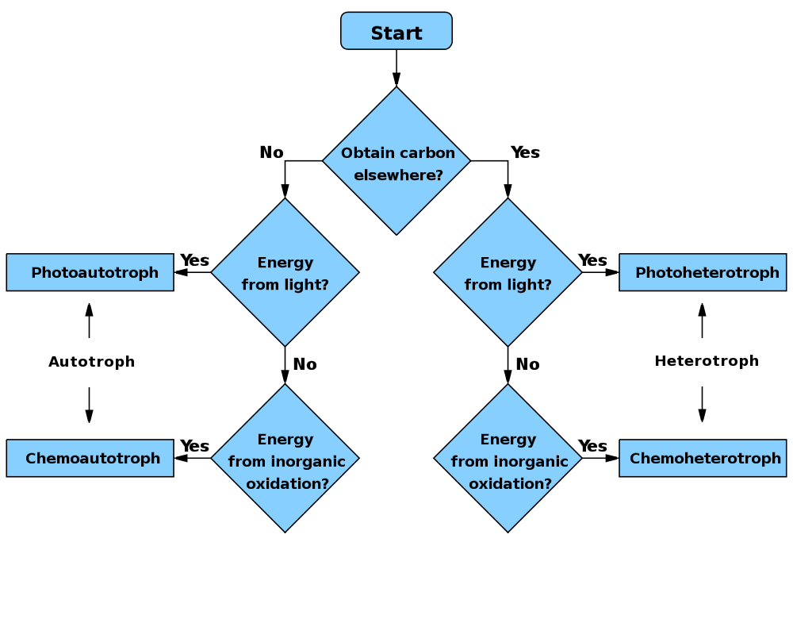
Figure 2.4. Flow chart comparing autotrophic (make their own energy source vs heterotrophic (must service carbon energy from outside of organism). WikiCommons user: Wickey-nl

While fungi are generally ‘non-motile,’ their cells are connected in such a way as to allow much of the cytoplasmic contents to flow through the tubular hyphae. In this way, a fungus can transport nutrients around its mycelium. While a fungus cannot move its existing body to a new location, they are able to exploit cytoplasmic flow in order to change or expand locations by growing hyphae in new directions, flowing their cytoplasm into the newly formed mycelial body, and walling off older sections of their mycelium.
Another implication of being unable to move is that fungi, like plants, cannot evade predators. Therefore, they are forced to come up with alternate defense mechanisms. Plants can develop thorns and spikes as part of their physical structure to discourage predators from attacking, however, they also produce a variety of novel secondary metabolites that act as defense compounds. Some fungi have developed physical defense structures, such as lacticifers among Lactarius or the physical toughness of many perennial polypores, but the production of secondary metabolites to ward off competitors or predators is ubiquitous. Some of these compounds include famous antibiotics, such as penicillin and its derivatives, or citric acid , a common food additive that is produced from Aspergillus niger fermentation. The plethora of secondary metabolites from fungi is astonishingly diverse and includes varying polyketides, terpenoids, terpenes, alkaloids, and peptides (Keller et al, 2005).

Animals and Fungi
There are a number of other key similarities and differences in plants and fungi, however, fungi are actually closer to animals than plants (Figure 2.2). Animals, plants and fungi are all eukaryotic, with DNA contained in a nuclei and membrane-bound organelles, representing their common lineage. However, plants split away from the ancestors of fungi and animals first. Today, fungi and animals are both placed within the clade Opisthokonta. A common trait of this clade is mobile gametes at some point in the organisms’ lifecycle. Only the basal lineages of fungi have retained motile gametes, as have humans (sperm). Most fungi no longer produce flagellated gametes.
Obviously, most animals are mobile organisms that are adept at moving around to find nutrients and food, and evade predators. The lack of cell walls is important for permitting contraction and relaxation of muscle cells, on which animal movement depends. The relative rigidity of mature fungal cells conferred by cell walls prevents contractile-relaxation of tissue, as well as ameboid-like formation of pseudopodia.
Both animals and fungi are chemoheterotrophic. In general, neither can produce their own food and cannot use light as an energy source. Thus, animals will ingest and then digest their food, whereas fungi digest (by releasing exoenzymes into the environment) and then ingest (by actively transporting nutrients back into the fungal body).
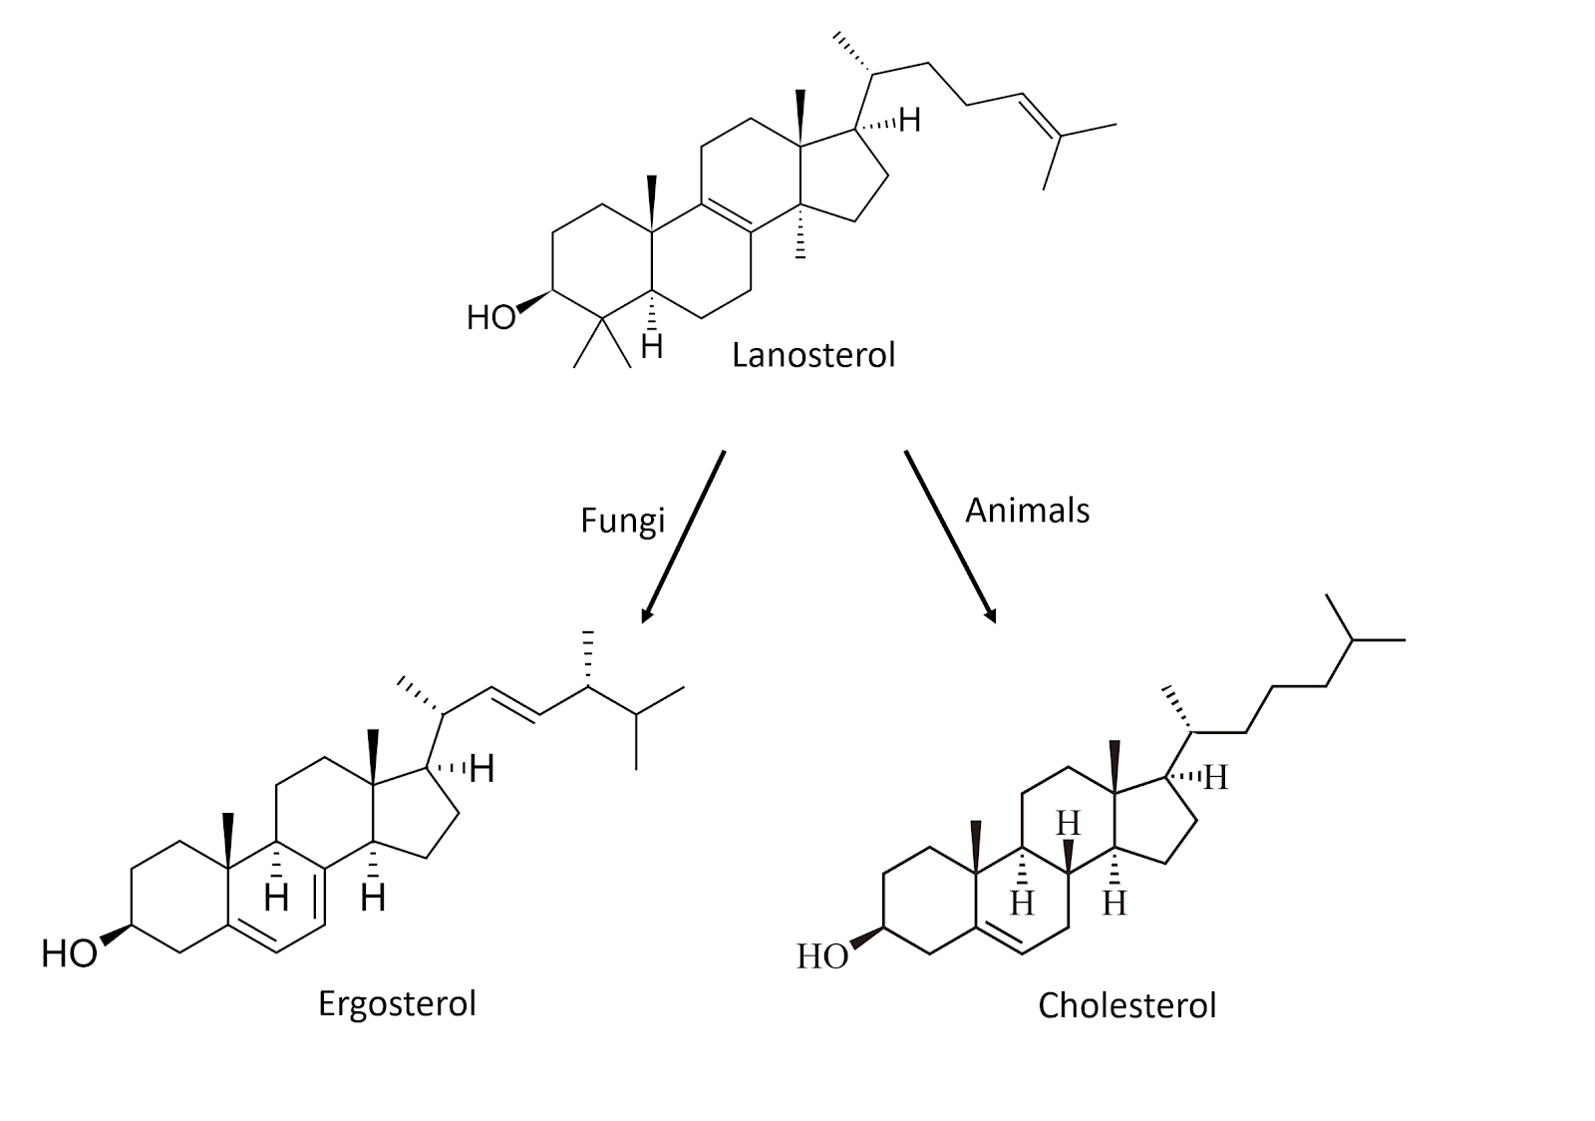
Figure 2.5. Chemical structures for sterol compounds found in fungi (Ergosterol) and animals (Cholesterol).

A physiological difference with practical implications between fungi and animals is the structure of sterols embedded in their cell membranes. Fungi synthesize ergosterol whereas animals synthesize cholesterol (plants also produce a diverse array of phytosterols). Both ergosterol and cholesterol are derived from the same precursor, lanosterol (Figure 2.5). Ergosterol and cholesterol serve similar functions including impacting membrane fluidity, cell signaling and other physiological processes.
One reason we are focusing on this particular molecular difference between fungi and animals is that we can exploit the ergosterol pathway unique to fungi in order to develop and apply selective fungicides. Compared to prokaryotic pathogens and disease agents, parasitic and pathogenic fungi have much more in common physiologically with their eukaryotic plant and animal hosts. Therefore, ergosterol and its biosynthesis are particularly important targets for antifungal compounds in agriculture, as well as veterinary and human medicine.
Fungi are an extremely unique and diverse group of organisms that contain some characteristics not found anywhere else in nature. The varied growth forms are reliant on external digestion of substrate by secreted exoenzymes, followed by ingestion of the predigested food via absorption and endocytosis. That fungus can be mono- or dikaryotic, some with many nuclei per ‘cell,’ is not only fascinating, but allows fungi unique physiological and evolutionary paths compared to uninucleate organisms.
Also, among filamentous fungi, cells can behave a little differently than one usually thinks of when considering traditional biological cell; the entire vegetative body, the mycelium, can exist as a complex network which nevertheless functions as though it is a single cell due to the ability of its cytoplasm to flow freely. Yeast cells are more akin to what most people think of when pondering single-celled organisms.

